Jack Johnston  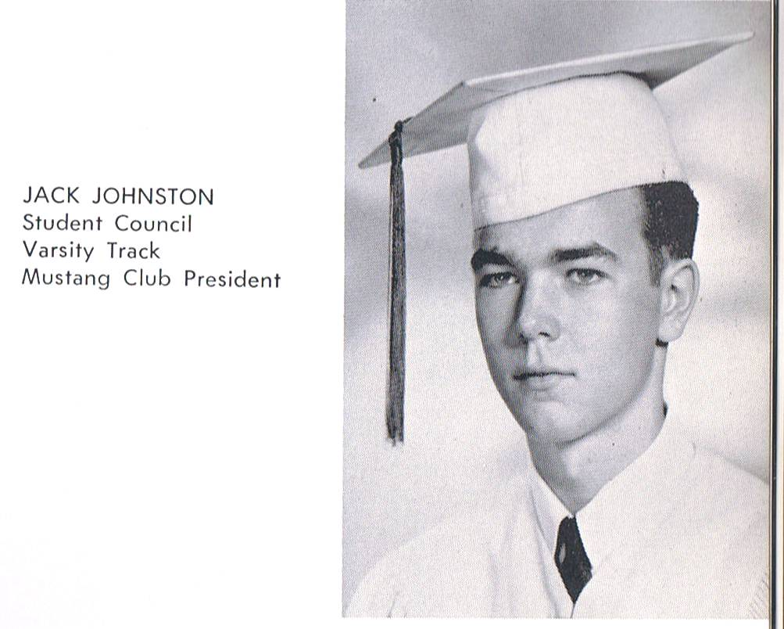
With the exception of one year, I’ve lived my entire life in El Paso since graduation. I spent that year away living with my older brother in Van Nuys, California, working in the auto parts business. I spent most of my free time over at the beach in Malibu drinking and trying to body surf.

Once I mastered both techniques, I decided to move back to El Paso where I began working at the El Paso National Bank as a computer operator. From there I went to Hortex (Billy the Kid) as a software programmer and stayed in the information technology field all of my professional career. I was an assistant vice-president at Mortgage Investment Company, and also worked at Darbyshire Steel Company as the comptroller. From there, I went to the El Paso Independent School District to help develop an in-house computer center. I retired from the school district as the executive director of Technology and Information Systems in 2004 after 20 years of service. After EPISD, I worked for a software company based in Austin that provided services to K-12 school districts. I retired from them late last year.

I’m now a full-time volunteer at Holy Trinity Retreat Center located in far east El Paso. I went from white collar to blue collar in a matter of 24 hours, and I love it. I can make and lay adobe, sheet rock, cement, tile floors, etc. If it has to do with construction, I’ve done it. I’m also an active parishioner at St. Pius X.

In my first marriage, I lived in the Coronado Hills area and my three kids from that marriage all graduated from Coronado High School. Two of them went on to graduate from UTEP while another went to NMSU. I have five grandkids from them.

I remarried and moved back to the Cielo Vista area. I live directly across from the fire station on the corner of Cessna and Edgemere. The house behind me was Tony Alexander’s, the house across the street was Rod Champney’s, and Ronnie and Bobby Martin’s is just down the street. I bought the house from Gladys McVey who was a principal at an elementary school, but I’m not certain I recall any kids at BHS with that name.

Laura (Jefferson Fox) and I have a daughter, Doris, that also graduated from Burges (2001), and was the 2000 Homecoming Queen. She’s a teacher at Chapin HS, and Laura works at Ysleta ISD in Special Ed.
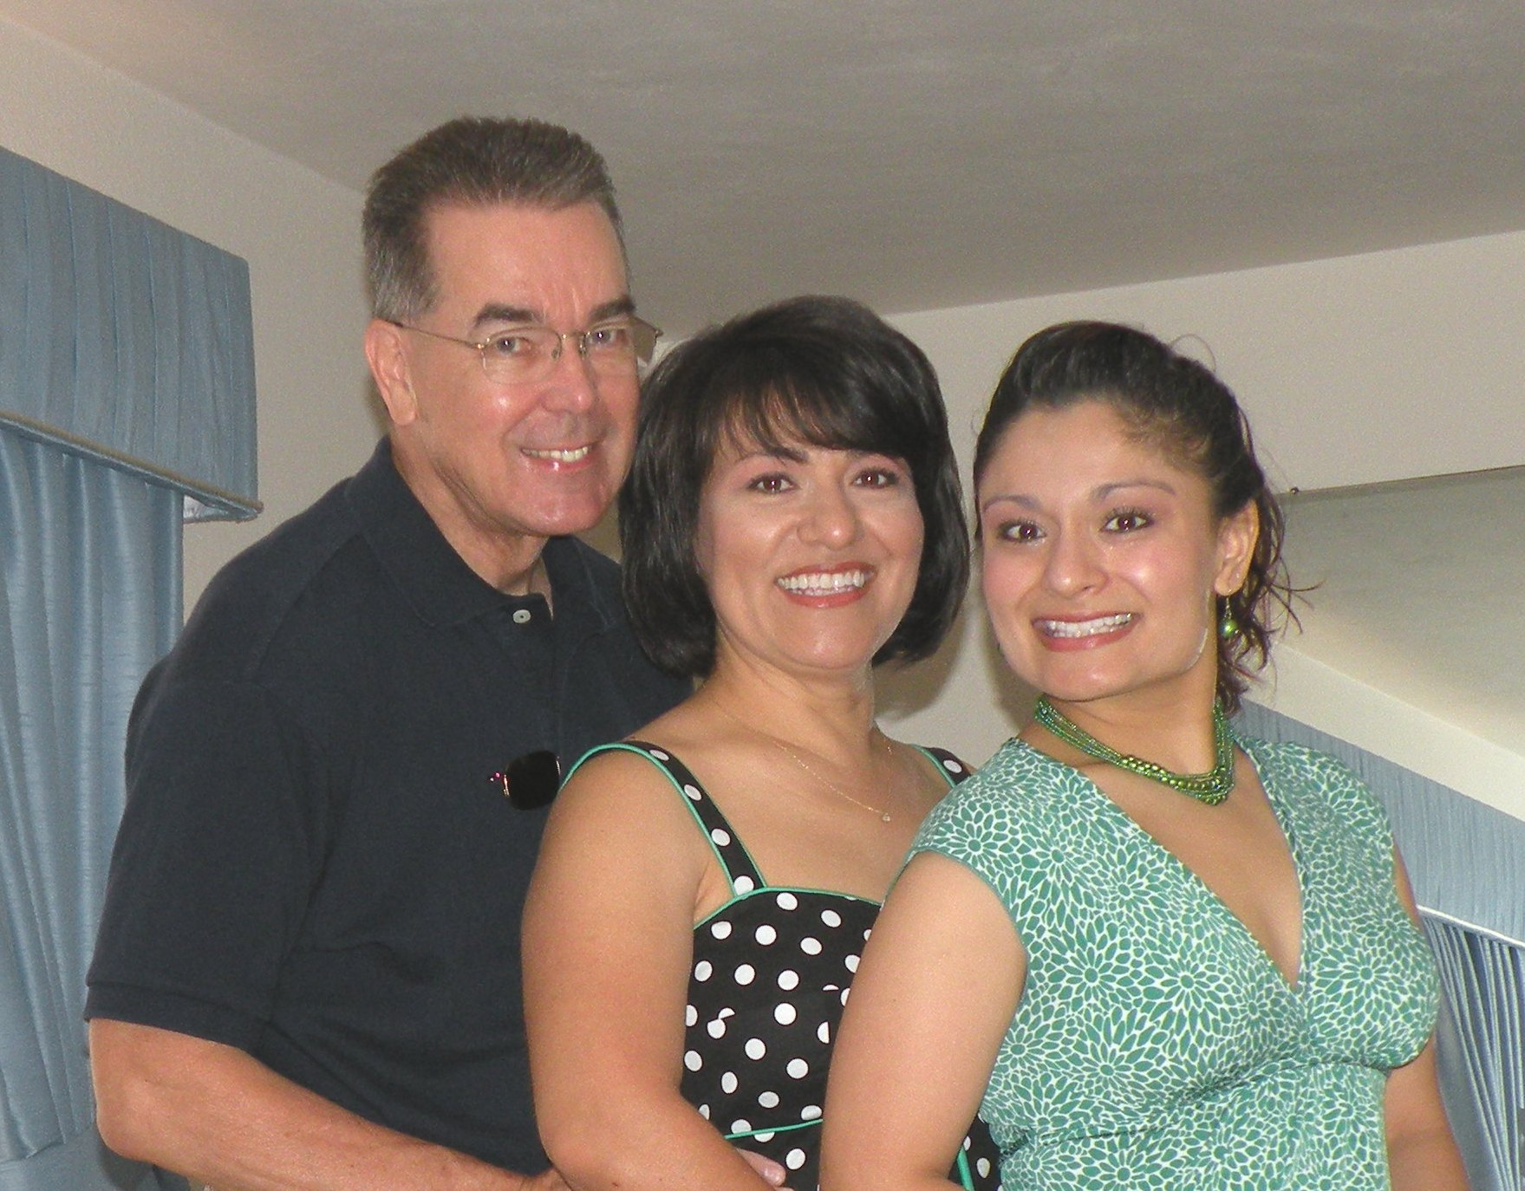
Here’s a photo of Laura, Doris and I.

