John Valles

After I left Burges, I attended Texas Western from September 1963 to May 1966. During the summer of 1966, I volunteered for the draft after an unsuccessful attempt to join the Marines with Tim Gahan under a program that was in place at the time which guaranteed that we would stay assigned to the same unit during our 2 year commitment. My mother found out about my pending enlistment & nearly had a heart attack. She made me promise that I would not pursue this perceived folly anymore. Consequently, I volunteered for the draft without my parents’ knowledge, but kept my promise about not joining the Marines. After my induction in September, I quickly rose through the ranks & received my commission as a Second Lieutenant in Field Artillery through the Officer Candidate Program at Ft. Sill in July 1967. I spent 2 years at Ft. Bliss in various assignments in Air Defense Artillery, before I volunteered for my assignment with the Phoenix Program in July 1969. I arrived in Vietnam on Labor Day 1970 & was assigned to MAVC Team 90 (Military Assistance Command Vietnam) in Tay Ninh Province, which was on the Cambodian border. My tour was extraordinary in many aspects & lead to lifelong friendships with fellow US & Vietnamese teammates.

After returning from Vietnam in 1971, I was reassigned to Ft. Bliss pending reassignment to Germany in early 1972. I decided to leave active duty in the spring of 1972 with the rank of Captain and joined the 12th Special Forces Group out of Arlington Heights, IL, where I remained on reserve status until late 1974. I returned to UTEP in the fall of 1972 and in August 1973, I married my wife Cyndee after a four month whirlwind courtship. I completed my degree in Marketing Management from UTEP in the spring of 1974 and shortly afterwards I went to work for Signode Corporation, a Chicago based Fortune 500 company. I have been with Signode, which is now part of Illinois Tool Works for the last 35 years in various assignments living in El Paso, Phoenix, and San Diego & currently in Dallas. I currently cover the western states & spend most of my weekdays on the road, returning home on Fridays for new adventures with my grandkids.

Cyndee & I relocated to Dallas after 30 years in San Diego in November 2006 to join our daughter Monique who was expecting the birth of our second grandchild that month. Our second grandchild, John Stephen Hohmann was born on November 24 & was welcomed into our family by his sister Olivia Diana Hohmann, who was also born in Dallas on September 4, 2005. I never thought Cyndee & I would leave beautiful San Diego after 30 years, but we could not bear the thought of not being part of our grandchildren’s life’s. When our only child Monique, married her USC sweetheart, Stephen Hohmann, we thought these two southern California kids would never relocate outside of San Diego, but when Steve completed Med School at UCSD in 2001 & opted for his residence & fellowship training in vascular surgery at Baylor Hospital in Dallas the hand writing was on the wall. They quickly became seduced by the Dallas lifestyle & decided to make Dallas their lifelong home. Steve is now a partner at Texas Vascular Associates at Baylor Hospital in Dallas.

Shortly after the birth of our grandson, Steve, Monique, the grandkids & their two dogs moved in with us & our dog & cat in our new home in Allen, while they rebuilt their home in the Preston Hallow area of Dallas. During our time together we had a great time watching our grandkids grow daily in front of our eyes. The 18 months we lived together are full of life long memories, with visits from Steve’s parents Ed & Lotte Hohmann of Glendora, CA & his uncle Paul, who lives close by in Plano. In May 2008 Steve, Monique, the grandkids & their two dogs moved into their new home, where we now spend most of our time when they are not at our home. We really enjoy our life in the Dallas area where we are looking forward to reuniting with old classmates in the area on October 15 when we will be attending a potluck dinner hosted by Ben Bell & Tim Stanley Class of 1964.

Life has been good to us in many ways. The Good Lord Blessed me with a GREAT FAMILY and friends from all walks of life from around the country & world. If you are ever in the Dallas area or if you need a good vascular surgeon give us a call.

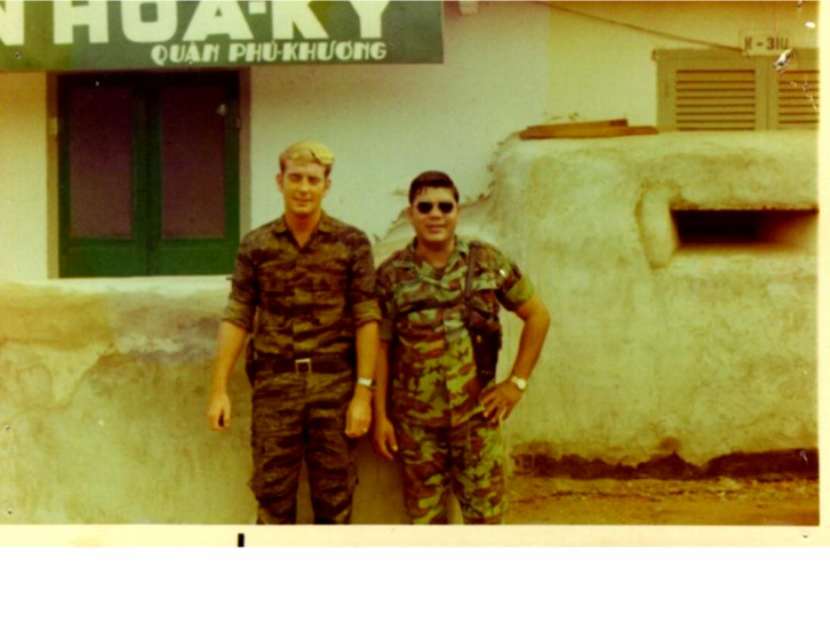
Rich Kidwell, my CIA Counterpart & Yours Truly
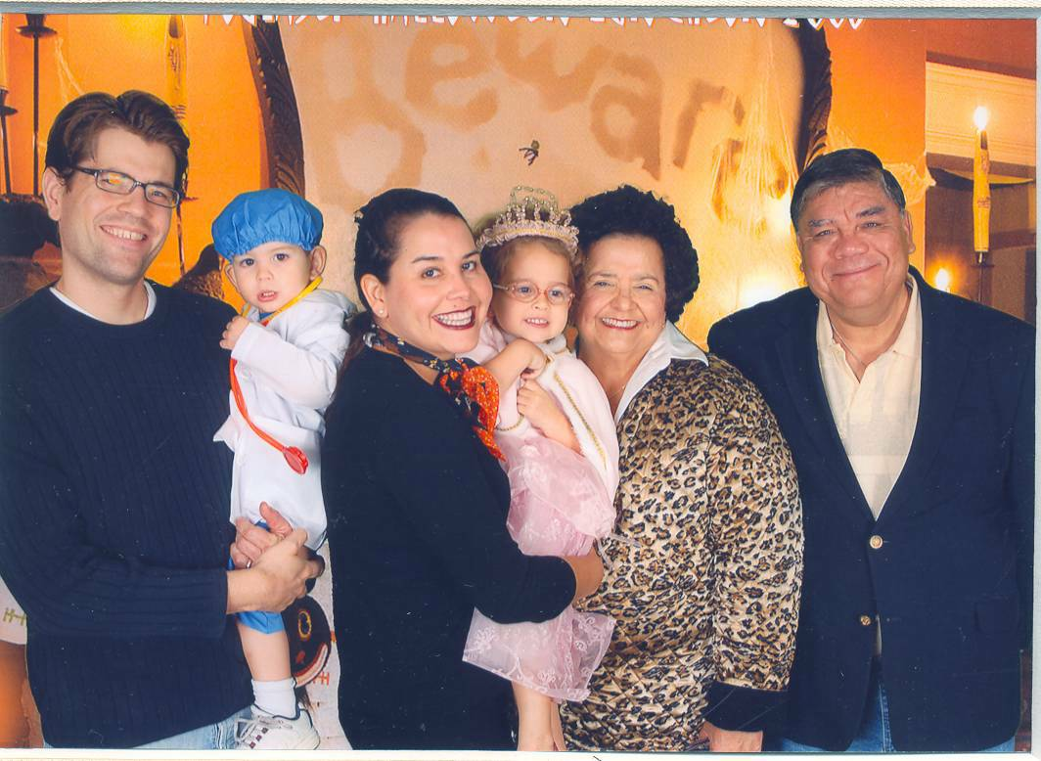

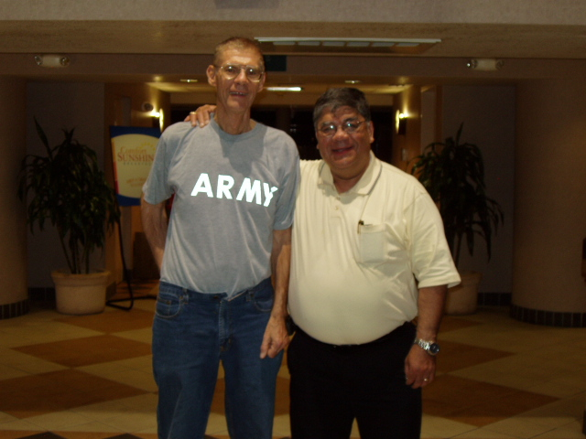
Bruce Beardsley (My Teammate from MACV Team 90 which was taken March 2008 in Phoenix. Bruce retired from the State Dept 2000 with the rank of Deputy Ambassador after serving in various assignments around the world most notable, he was the first State Dept official to visit Hanoi in the early stages of the Clinton Administration & was involved in the initial negotiations to re-establish ties with North Vietnam)

The Valles-Hohmann family Halloween 2008

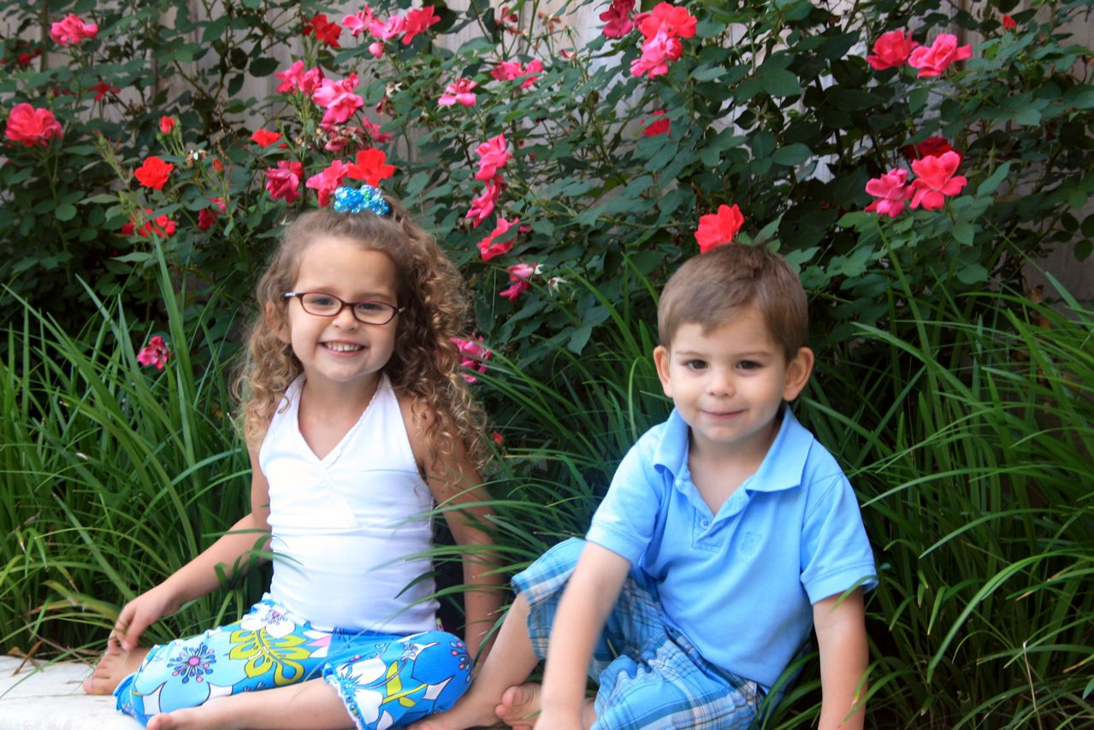
Olivia & John Stephen July 2009

