Tim Stanley,

In my senior year, at Mr. Kelso’s recommendation, I applied and was accepted at the University of Oklahoma. The day I showed up to enroll was the first time I had ever seen the place; so much for visiting schools ahead of time. I was fortunate enough to have a Navy NROTC scholarship that paid tuition, books and $50/month as well as being a Texaco Scholar my junior and senior years . I graduated with a BS degree in metallurgical engineering.

In spite of a class mate’s warning, I interviewed with Adm Rickover for the nuclear power submarine program and was accepted. (Another story in itself) I went through the nuclear power training (New London, CN, Bainbridge MD and Saratoga Springs, NY) but opted out of subs and ended up on the nuclear aircraft carrier of my choice (i.e. ‘Starship’ Enterprise with one 8 month Westpac ’71-72). Seeing Vietnam from an aircraft carrier was much like being off of southern California. I then spent two years at the UNM NROTC unit in Albuquerque, NM. Great duty no sea water for miles. In the summer of 1974, I left active duty in the Navy with a wife and a daughter (1970) and son (1973) and a new MS in Nuclear Engr.

We then moved to Houston to build commercial nuclear power plants. Here I met two other irradiated Navy nukes and we went to law school at night. (Awful). As for selecting patent law as a career, I can only blame my high school chemistry teacher (Mr. Crawford) for placing that thought in my mind my sophomore year. If my high school speech teacher (Mrs. Cooper Burges in bloom 1958) could only see me now. No more shaking at the podium!!

After law school, I went through a variety of patent attorney jobs: the first with a private law firm in Houston, then an oil company in Tulsa (9 yrs) then to Lockheed Martin, first as the chief patent counsel at Sandia National labs (read weapons of mass destruction) in Albuquerque and then to Orlando and now Dallas (more subtle things now like the Hellfire® missile!).

I got back in the drilling navy reserves in 1982 (Coincides with going to work as an associate in a private firm. I needed the money.) and stayed there until I retired in 1999 as a Captain (That is almost 35 years in the Navy from the day I enlisted out of high school). Spent most of my drilling reserve time on a variety of operational staffs. Who would have thought? Certainly none of my NROTC classmates who voted me least likely to make LT(jg)!

Shortly after graduation in January of 1969, I married Connie Holland from Midland, Texas. I met her while working for Texaco in the summer of 1968 as part of my Texaco Scholarship. It took four more years in the Navy before I made what I earned(?) that summer!

In spite of my best efforts, my wife and both children are all Oklahoma State grads, so you can imagine the hell I have lived through.

During the past forty odd years I have re-acquired an old hobby and started one new one. As to the old one, my mother did NOT through away my old baseball cards! I now collect older cards starting with the tobacco cards of 1909 and have in fact finally completed the 1959 Topps set I started in 8th grade. As to the new hobby, I am now driving my third Corvette (1996 torch red coupe, 1999 Navy blue convertible and 2006 Monterey Red coupe) and have been at one time or another president or board member of various Corvette clubs.
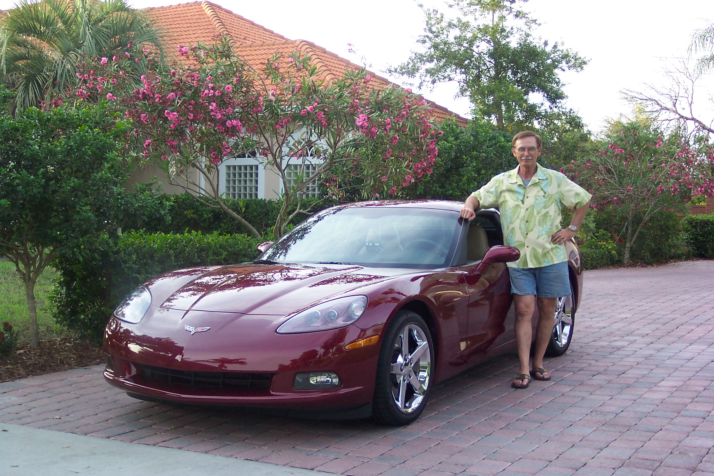
Me today just before we moved from Orlando to Dallas.

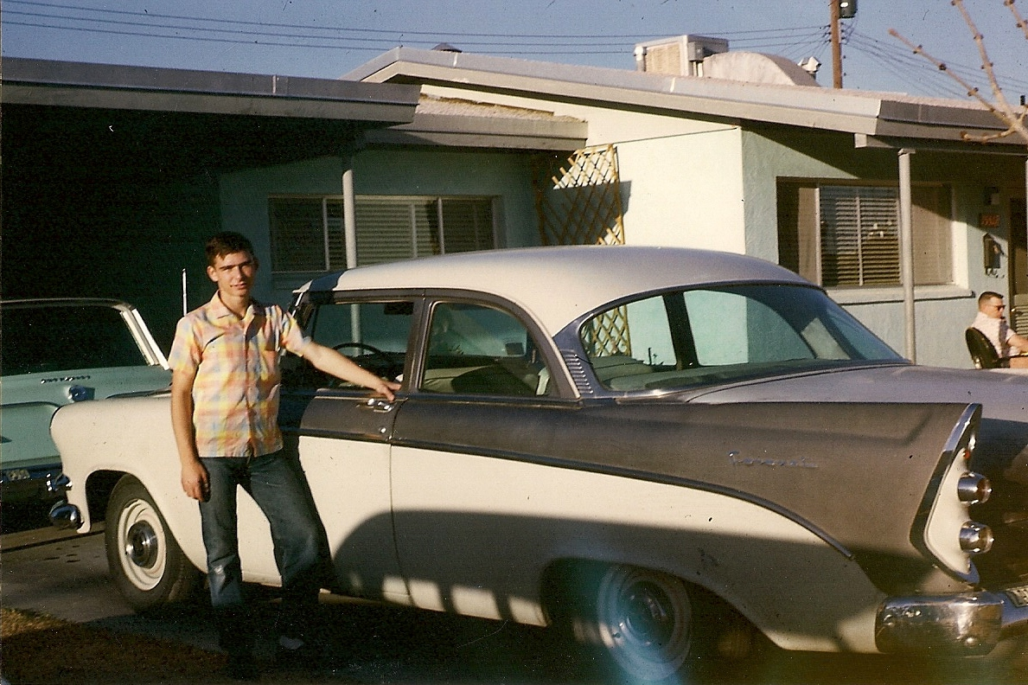

Me at 16 and my first car a 1956 dodge

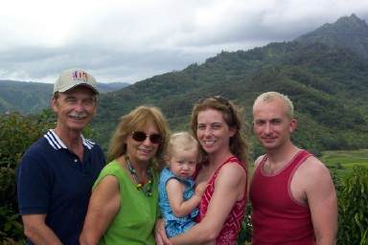
The Stanley clan on vacation. Me , wife Connie, granddaughter Kasey, daughter Christie, and son Brian

