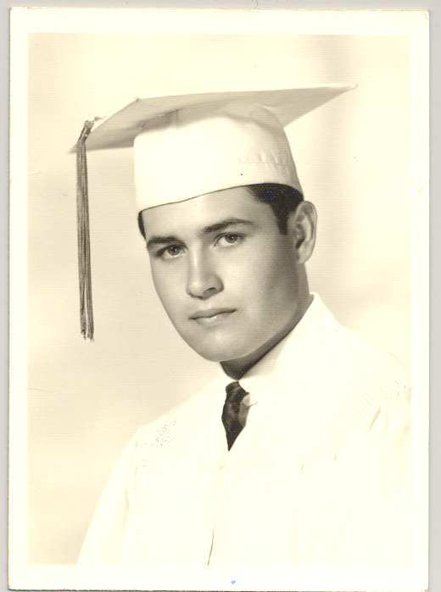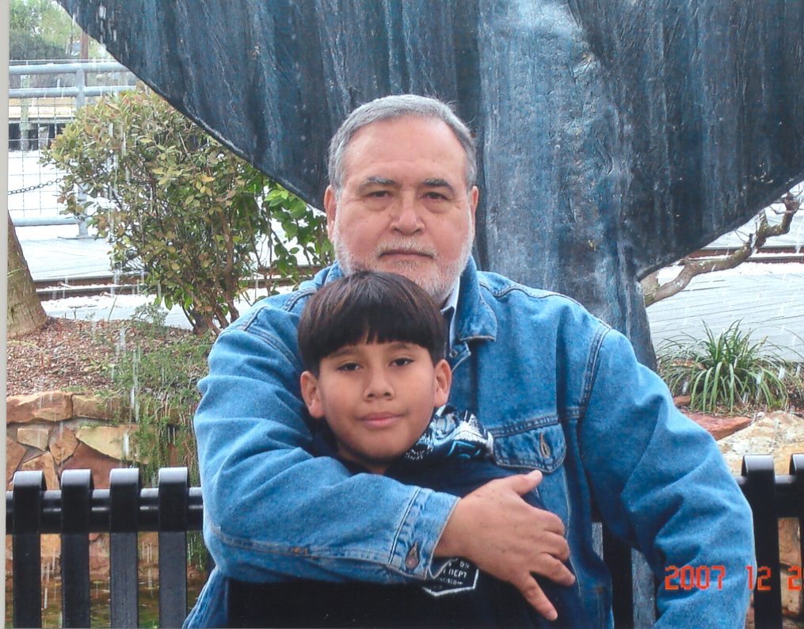

In 1966, Mary McCarthy wrote Doris Grumbach, her biographer: "In examining my life-history you probably don't give enough importance to friends" and went on, in case Grumbach missed the point: "I would date my own life more by friendships than by love affairs on the whole. Friends and teachers; for me it has often been the same thing." Damn McMarthy --she stole my words. How you found me is beyond my understanding: I haven't found myself yet!.

Back in BHS I was some sort of loner --kept mostly to myself and my books. So, being kind of shy, I guess, or an introvert (there's no explanation, other than my probably being a bore), I didn't have many close friends. I guess you could say that I had school-day friends rather than week-end friends. But thanks to your contacting me I was able to get in touch with some very dear friends --especially Gloria Saldaña, whom I don't write to as often as I should, and Toni Wintroub, who fears may have scared me off-- I had back then. I wonder what ever became of Howard Alexander, Mike Kennedy, Rusty Bryan, Don Powell, David Eads (I envied his cameras oh sooo much), Eddie Beard: they were --are-- fun. Your contacting me also brought some very sad news --the fact that Kathy Brown and Kaye Jones had passed away as has, recently, Steward Nance.

I was very happy at BHS, though, and have quite a few fond memories of the people I met there (the Pegasus and Stampede staffs), including Mr. Ferrell, Mr. Nelson, Mrs. Beaver and Mrs. White (I wrote her a letter in 1964, thanking her for teaching me to think --no kidding-- and she sent me a thank you note which is floating in my universe of papers).

I enclose two photos: my graduation photo (the before photo: I hadn't realized I looked like Droopy) and a photo taken in December 2007, with my (then ten- and now) twelve-year old son Daniel, whom I love deeply (the after photo, now looking like Wally Walrus).

Victor Hermosillo

